How to deploy Anubis’s client and server

## Network request flow chart

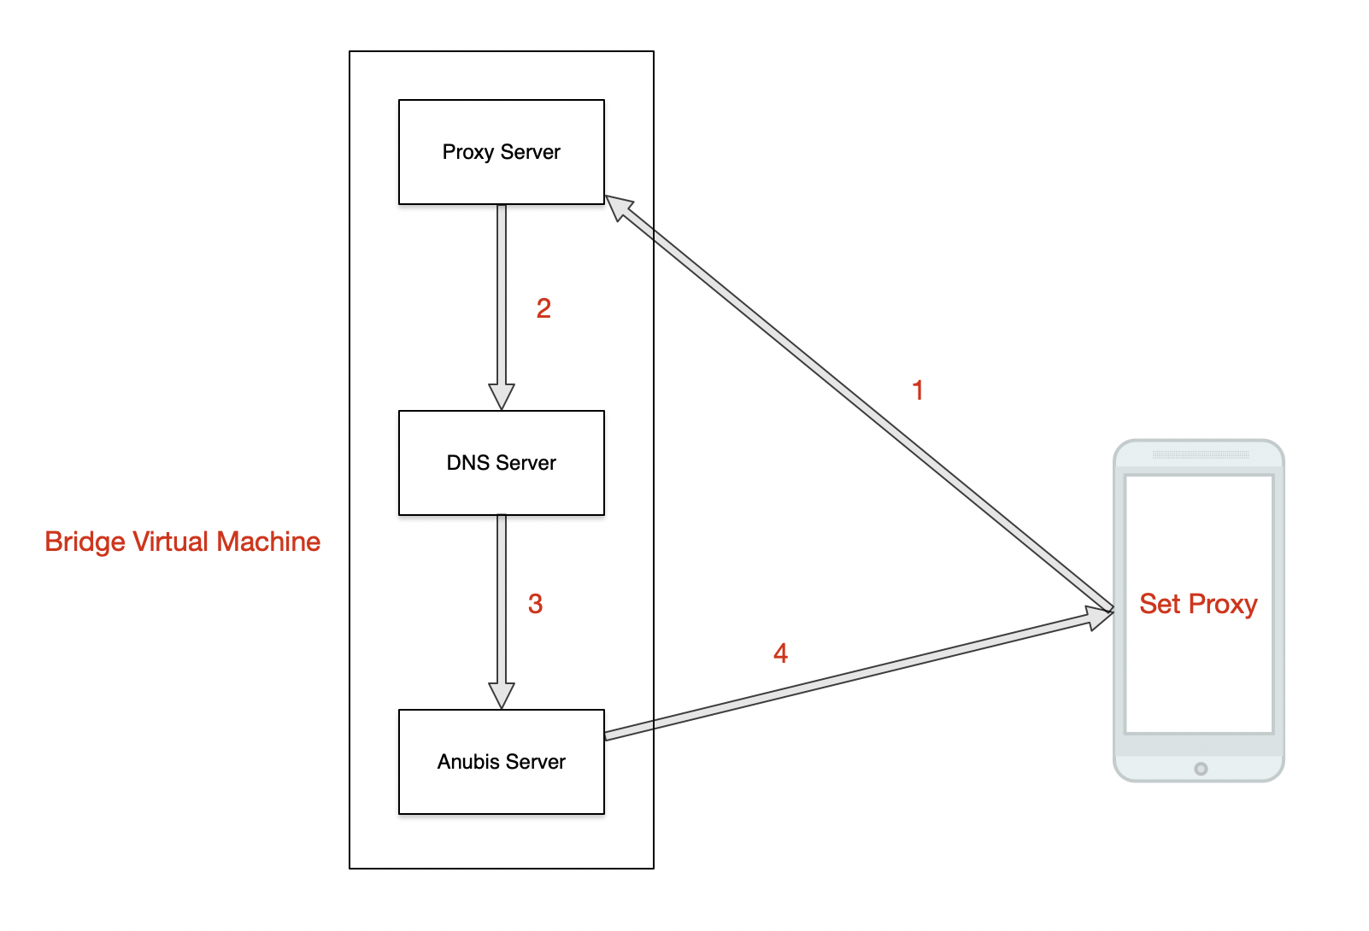

## How to deploy your Anubis’s server

Server runtime environment:

* Virtualbox 6.0

Step1: Install VM

**Note: Bridge Virtual Machine**

* Unzip Centos.7z, Use Virtualbox open virtual machine (root password is 620524)

## Network Configuration

* Get your IP

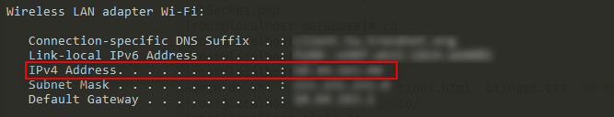

* Add proxy for phone:

Proxy hostname: your IP

Port: 8888

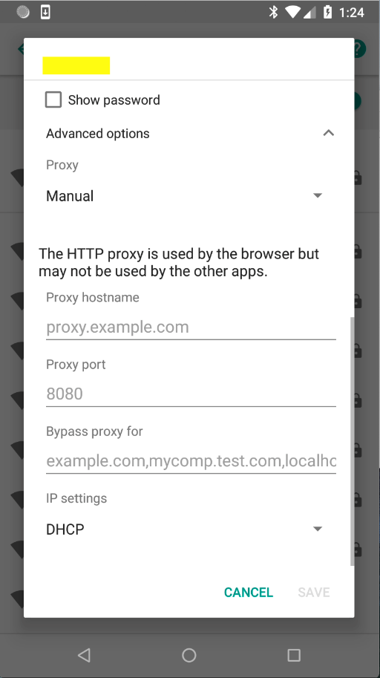

## How to spread

The victim received a spam message, open link in SMS, download malware and install.

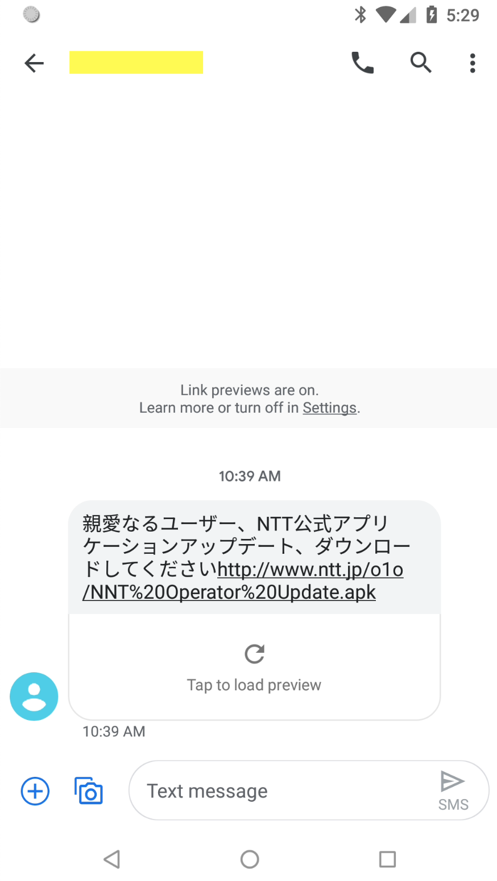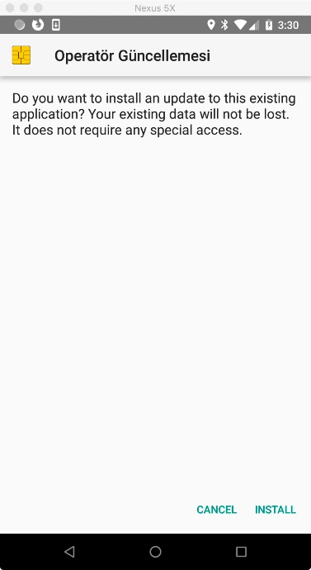

Click it when installation is complete, and give it “Accessibility” permission.

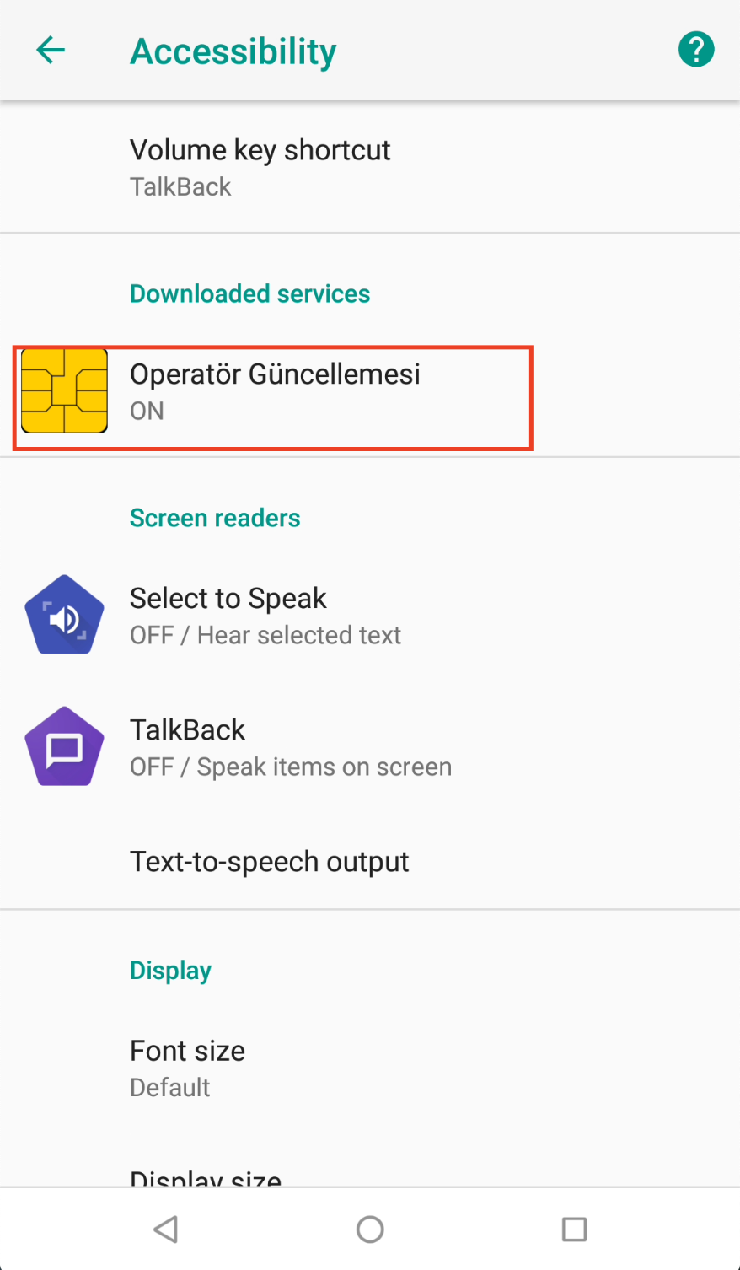

## How to use your Anubis’s server

**Introduction**

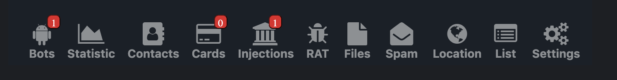

Bots: Show victim’s device, send command to victim’s device and change bot setting

Statistic: Show Bots analysis

Contacts: you can download victim’s contacts

Cards: Show Bank cards (we can’t find that JP Bank uses card number and password to login)

Injections: Injections shows victim’s bank username and password and you can view victim’s SMS, contacts and all installed app

RAT: RAT show SD card and you can send command to victim’s device, next bot uploads the file to the C2 Server

Files: you can download file from C2 Server

Spam: Spam is target person’s phone number

Location: Location is victim’s location

List: list is commands in the queue, because of delay between bot and C2 Server

Settings: Bot settings, such as C2 Server address

**Support Command**

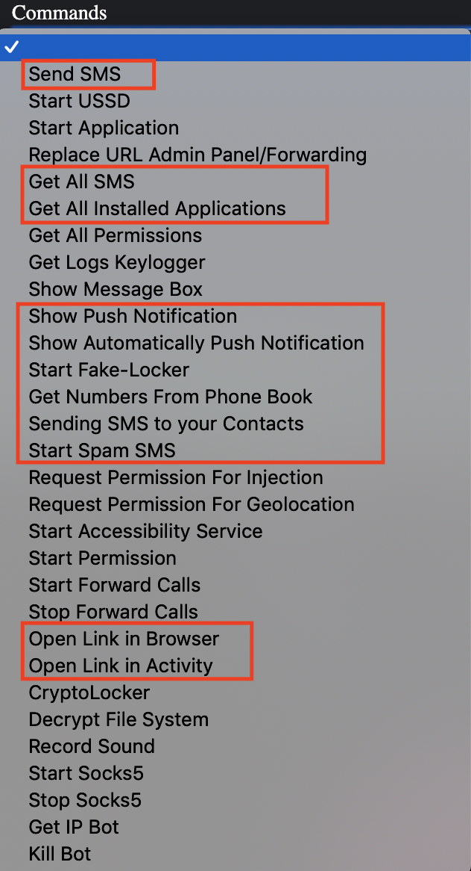

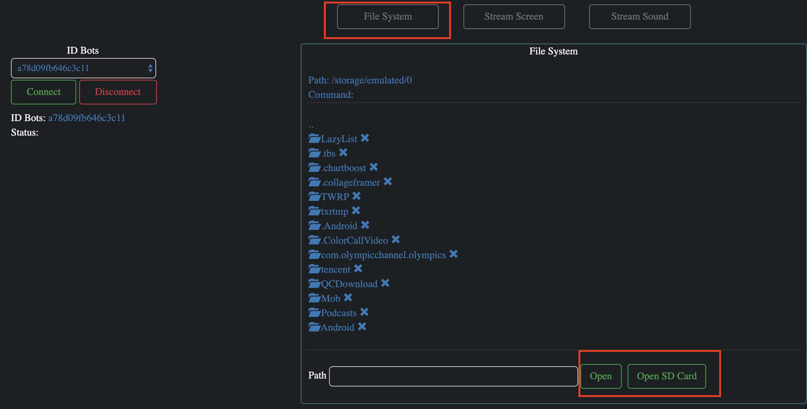

Step1: Login

Login Address:

Host: <http://www.ntt.jp/anubis/login.php>

UserName: admin

Password: admin

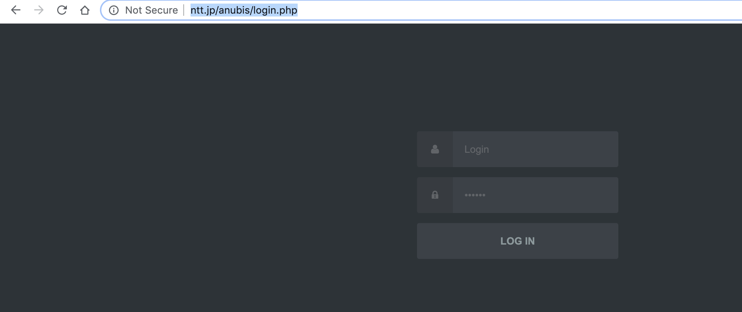

Step2: Install Anubis client and give it Accessibility permission. Then remote control it

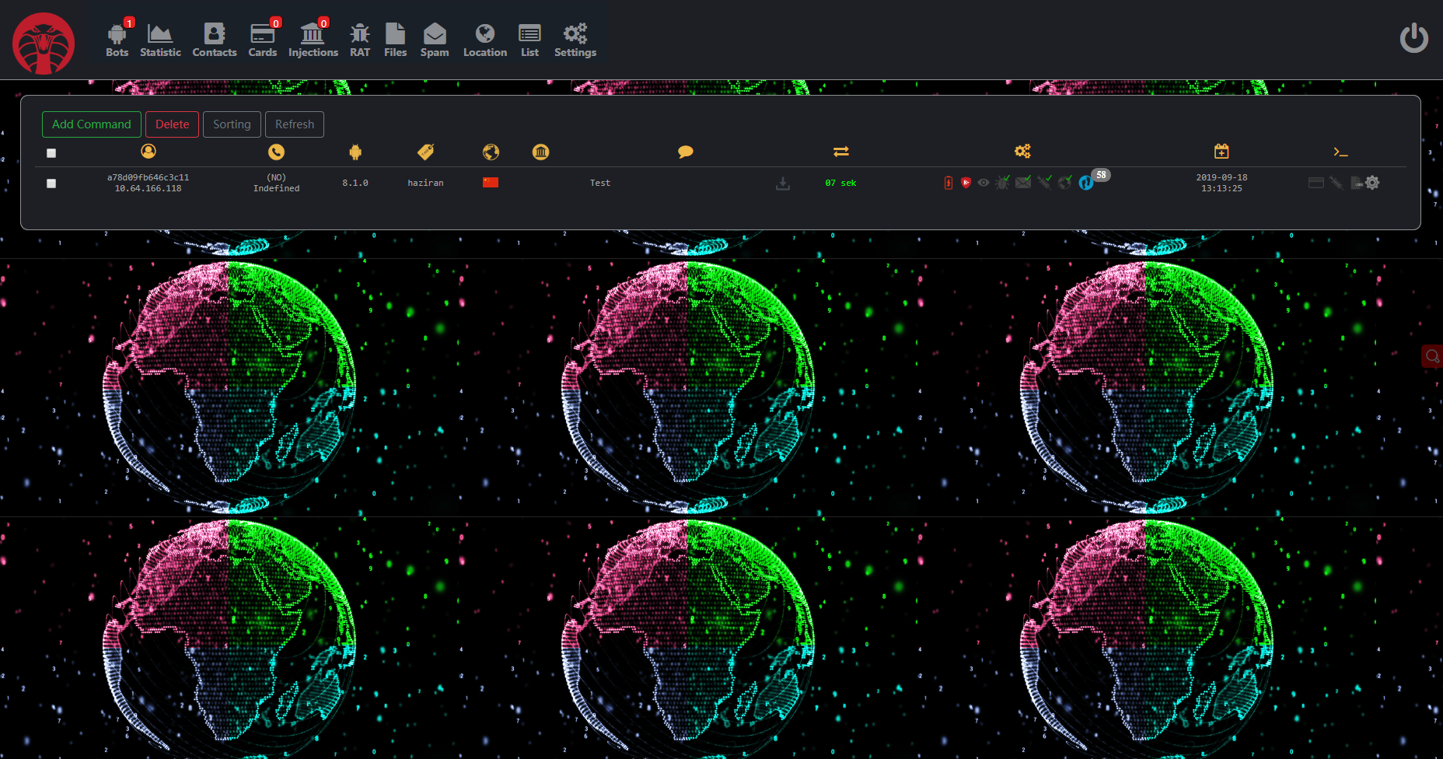

Step3: commands

3.1 Inject JP Bank, such as “住信SBIネット銀行”

Click “Setting” button, select “(JP)jp.co.netbk”, and save setting

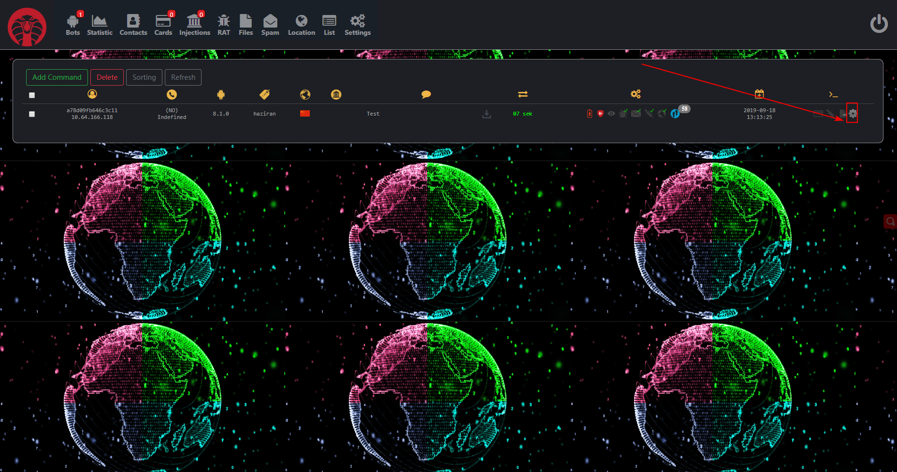

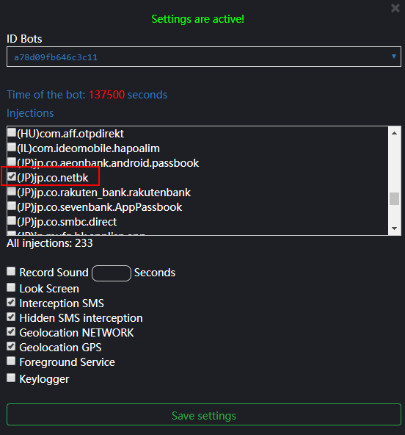

Then open the “住信SBI” app, you can find a fishing interface.

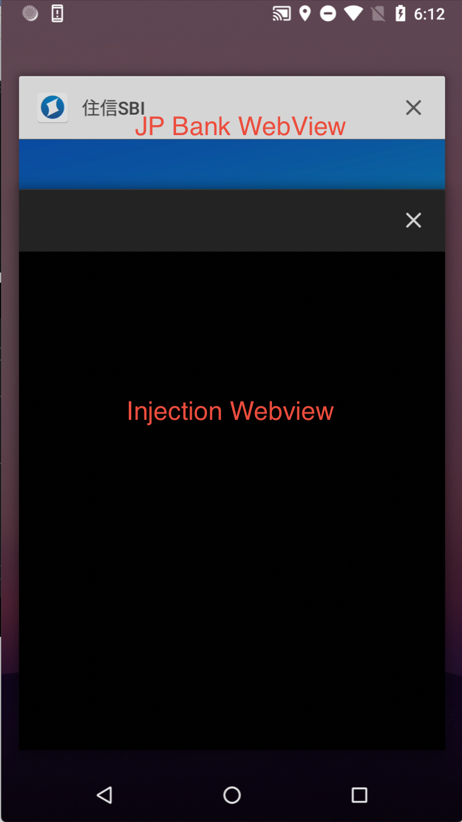 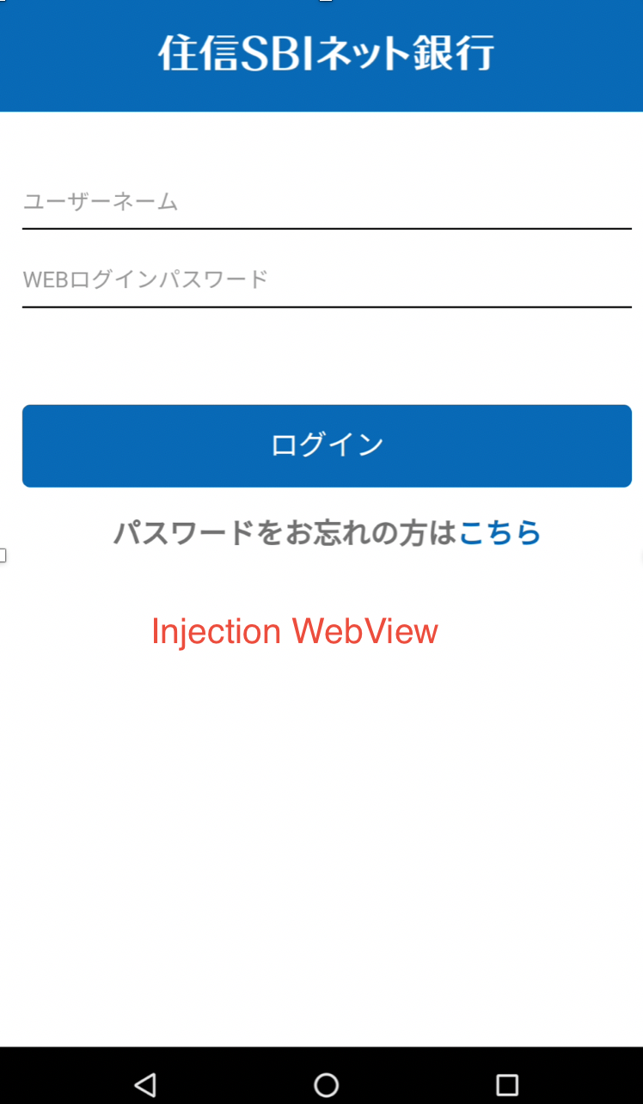

If you input your user name and password. Your info will send your server.

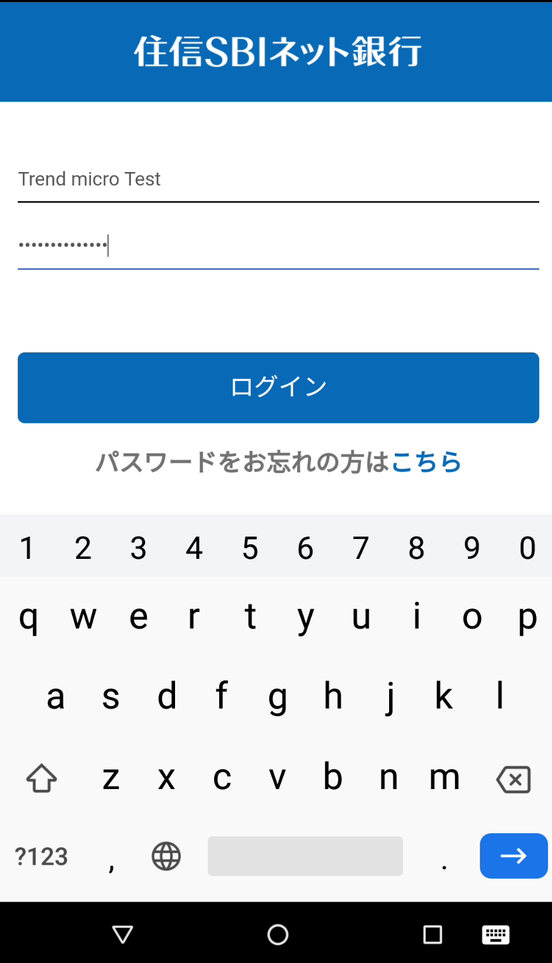

How to view user name and password.

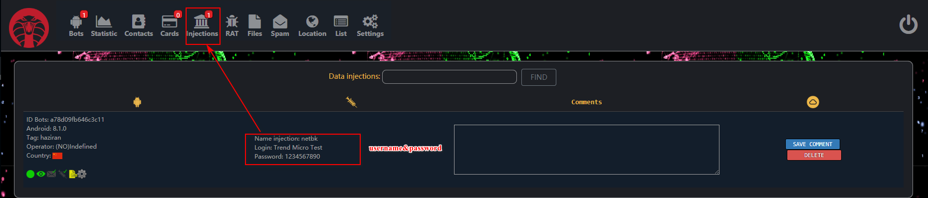

3.2 Get victim’s location



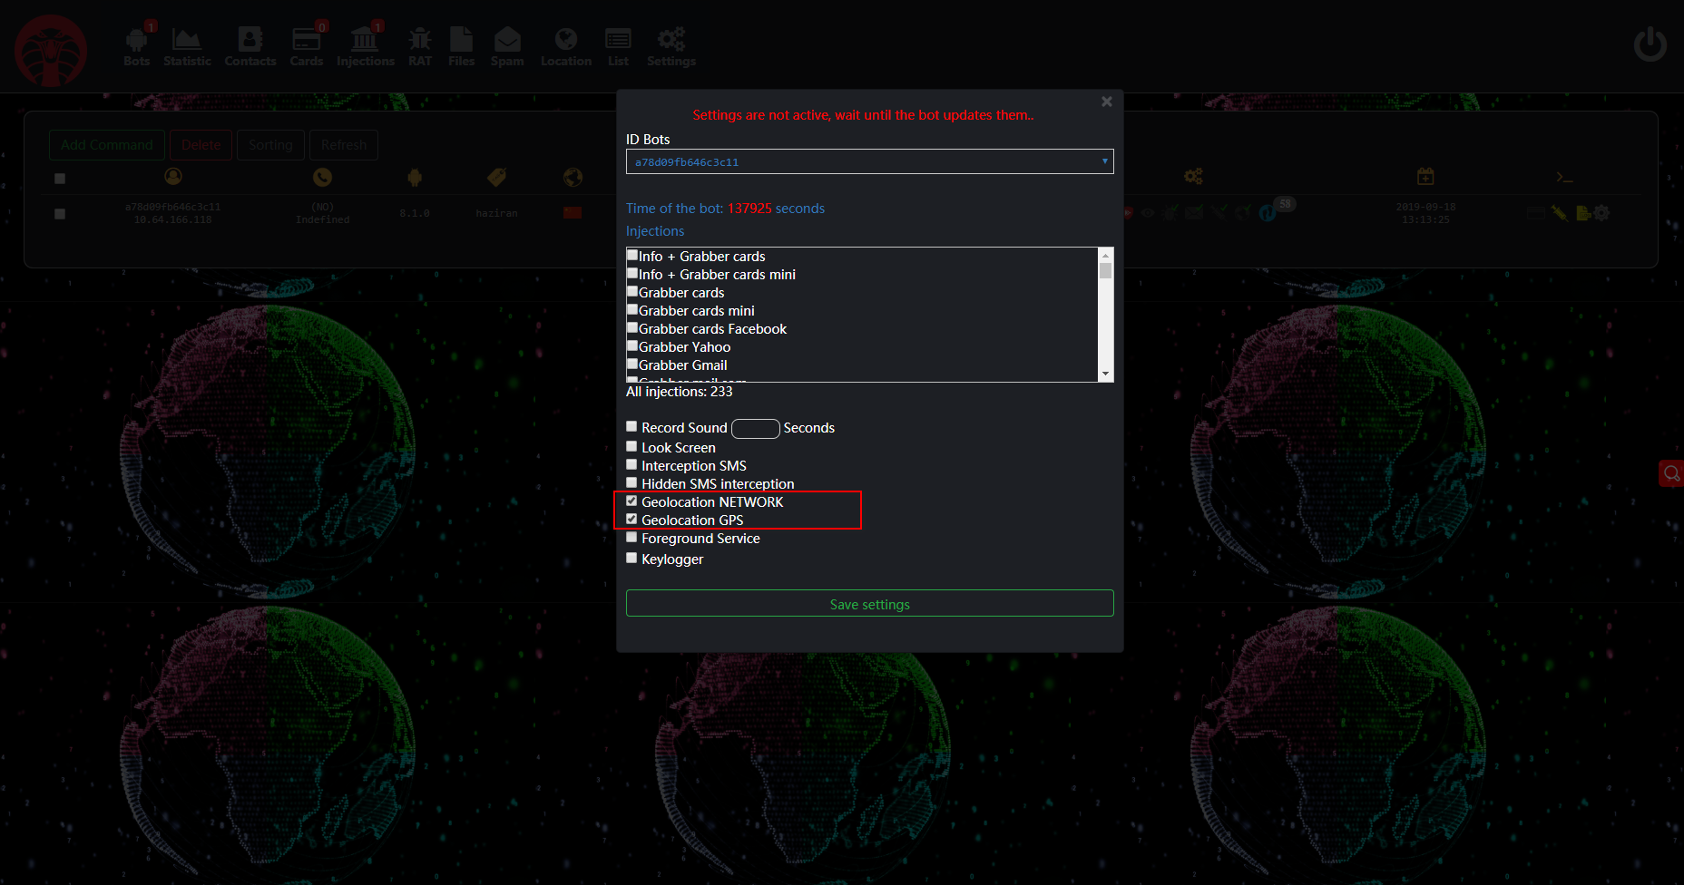

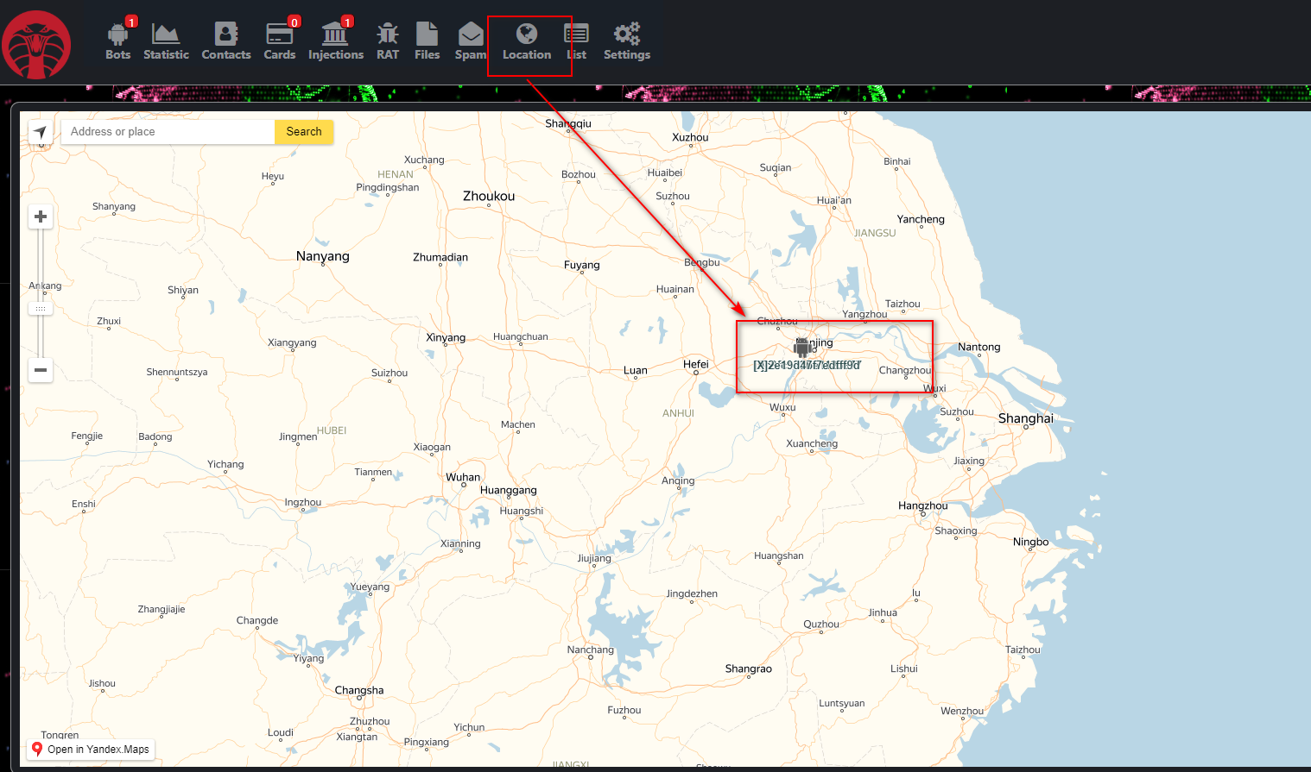

3.3 View sdcard and download picture

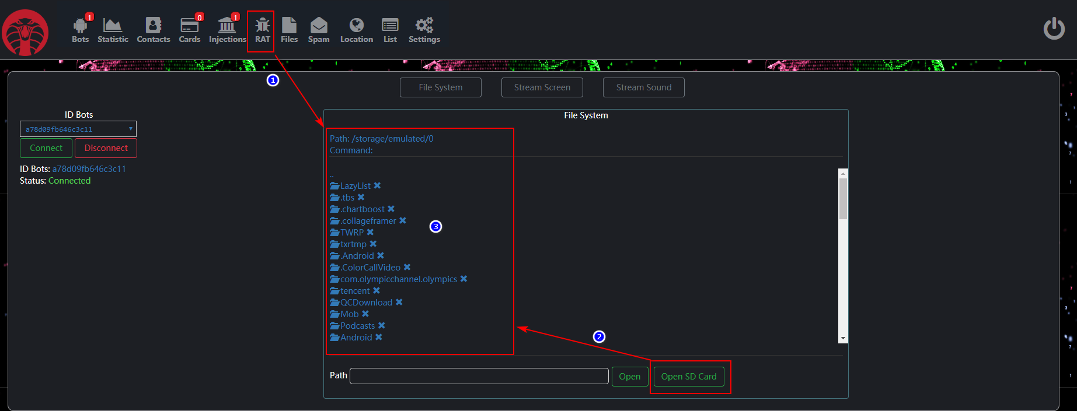

Send the download command, the bot uploads the file to the C2 Server.

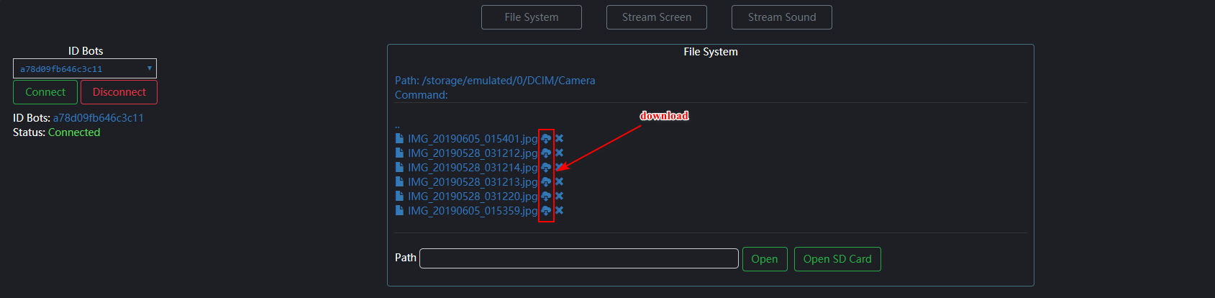

Click Files. Next you can download file from C2 Server to local.

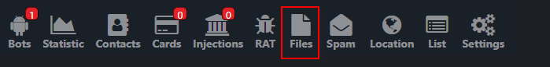

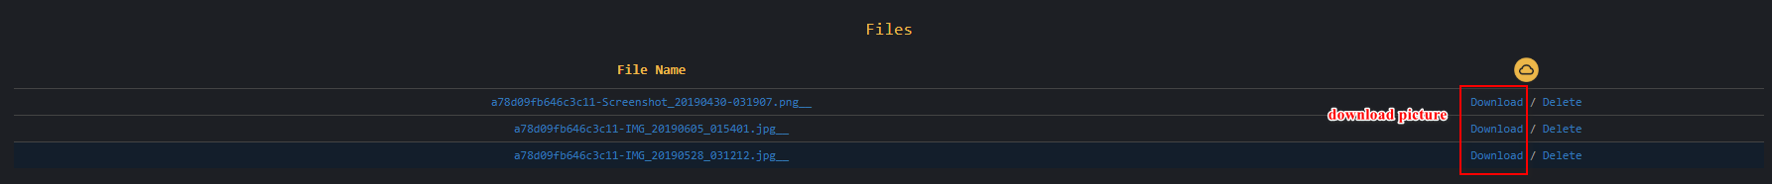

3.4 Get all SMS



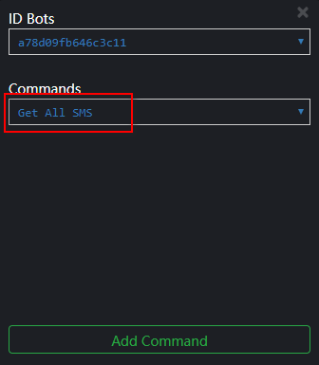

View SMS



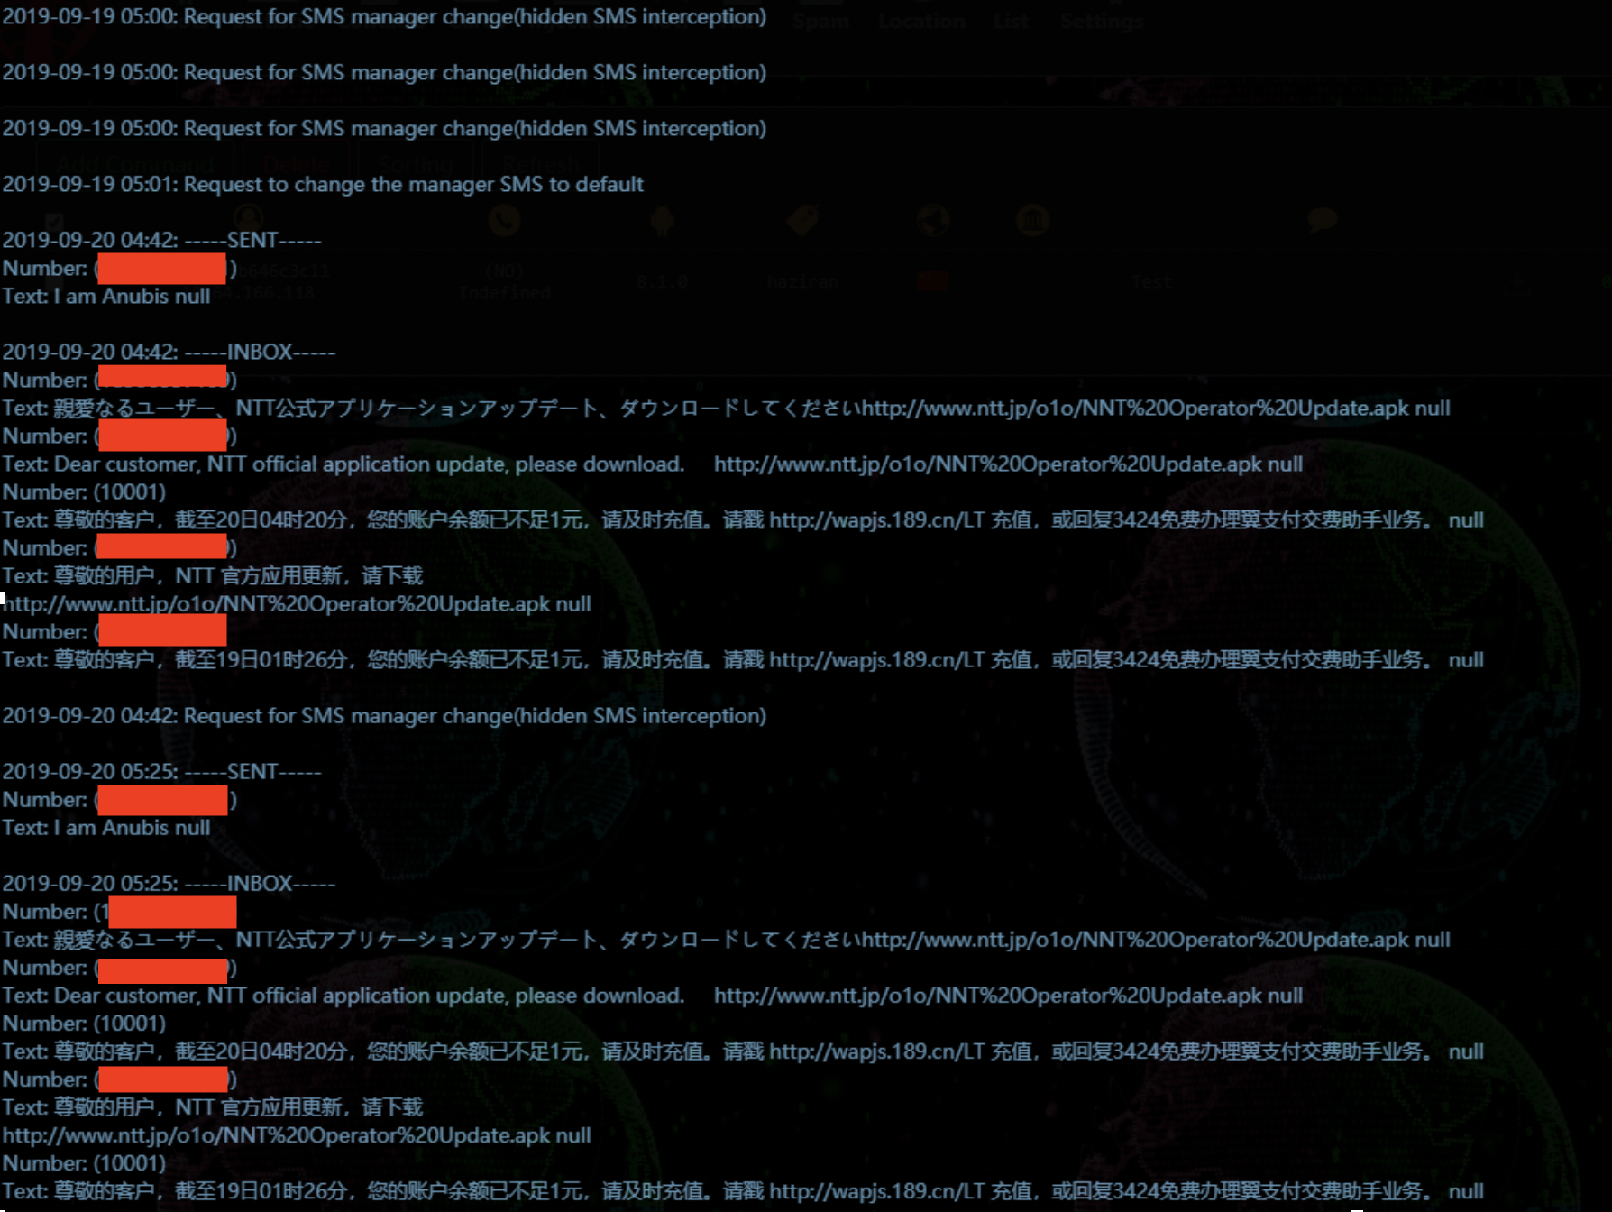

3.6 Get all contacts



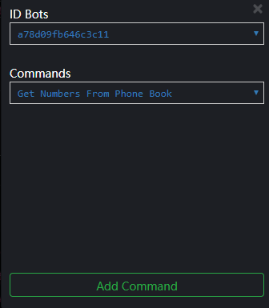

Click and download contacts

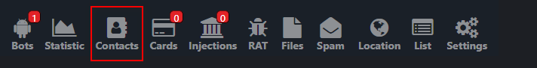



You will download a html file, open with browser.



3.5 Other command, such as fishing notification

Click “Add Command”, select command as “Show Push Notification”



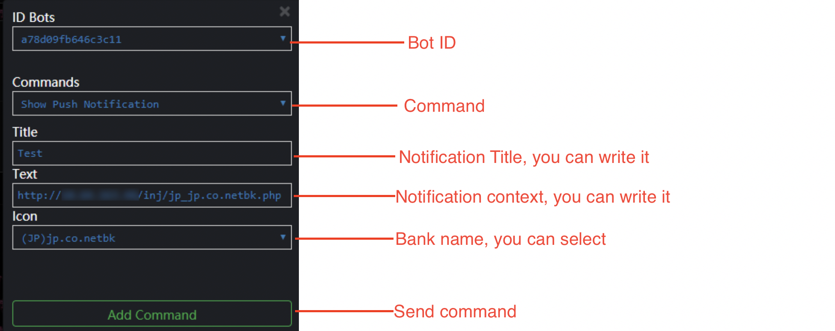

View fishing notification and open fishing interface

